Proper movement patterns and muscle training for postpartum recovery

AS Ida-Tallinna Keskhaigla
Ravi 18, 10138 Tallinn
Rg-kood 10822068
Tel 666 1900
E-post info@itk.ee

Patient information

The purpose of this leaflet is to give recommendations to women who have given birth for postpartum recovery. The body undergoes major changes during pregnancy and after childbirth. After childbirth, mothers usually pay full attention to the newborn and forget about themselves. After childbirth, it is recommended to wear a postpartum belly wrap every day for the first 6–8 weeks. Abdominal support helps to maintain correct posture and reduce discomfort in the abdomen and lower back. Within six months after delivery, a woman’s body needs time and special care for recovery. Women recover from childbirth at different speeds and in different ways.

The first 24 hours after childbirth

When getting out of bed or transitioning from sitting up to lying down, roll onto your side first. Avoid twisting movements of the body. Before standing up, make sure you do not feel lightheaded. Change body positions during the day; move around. Start with pelvic floor exercises. Avoid lifting weights; do not lift anything heavier than your baby.
When turning in bed, bend your knees one by one while supporting your belly with your hands. Roll your shoulders, hips and knees to the side at the same time. This way you avoid twisting your body.
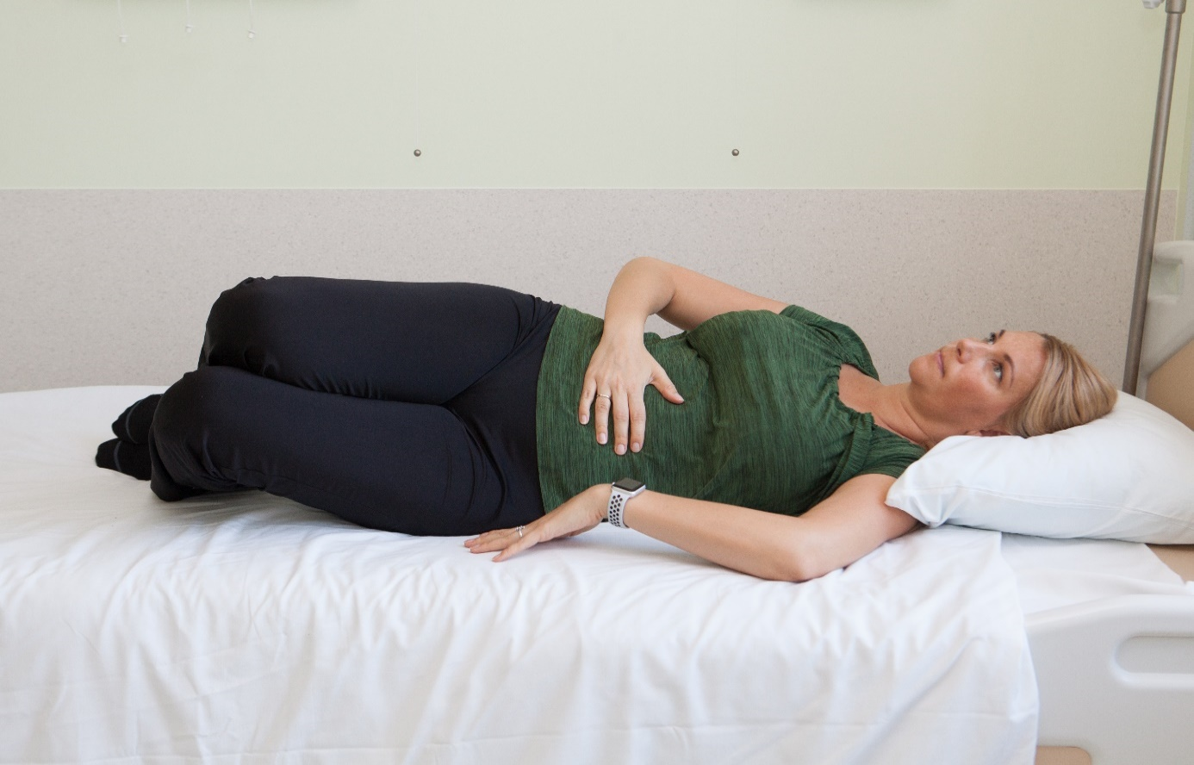

To get into bed, sit on the edge of the bed. Support both hands on one side of the bed. Slowly lower yourself onto the side leaning on the elbow and then on the shoulder. Pull both legs onto the bed. Roll onto your back.
To get out of bed, bend your knees while lying on your back and roll onto your side. Use your elbow and arm to push yourself up and swing your legs down over the side of the bed.
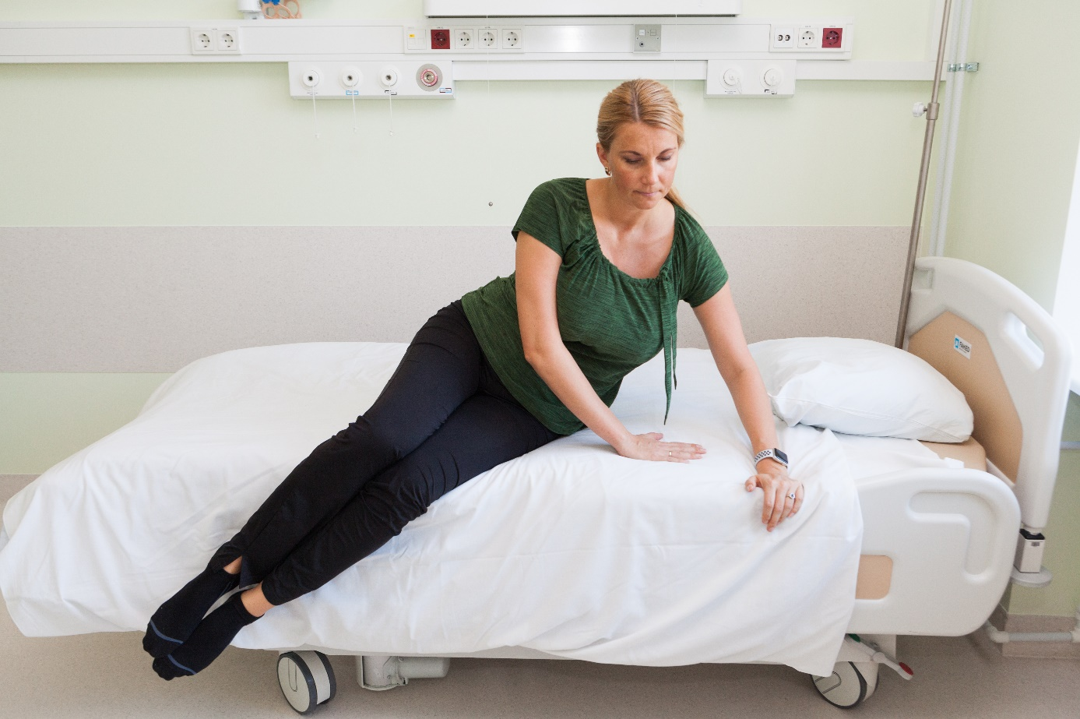
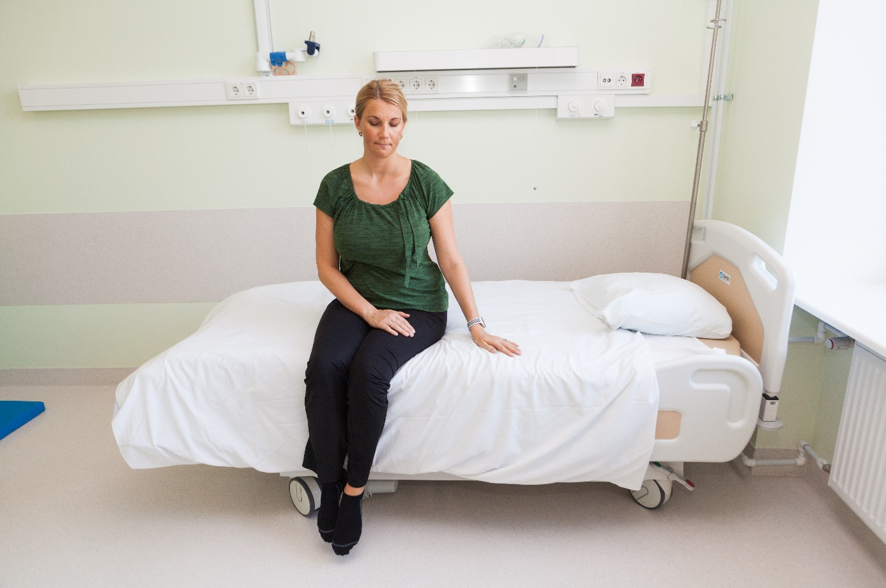

First weeks

It is important to rest, focus on caring for the baby and keep in mind the principles of ergonomics when lifting the baby and changing diapers. Avoid lifting your baby in a car seat, as it places strain on the abdominal and pelvic floor muscles.
Use ergonomics in everyday life. For example, do not hold your baby on one hip. When carrying your baby, constantly change sides and body positions.
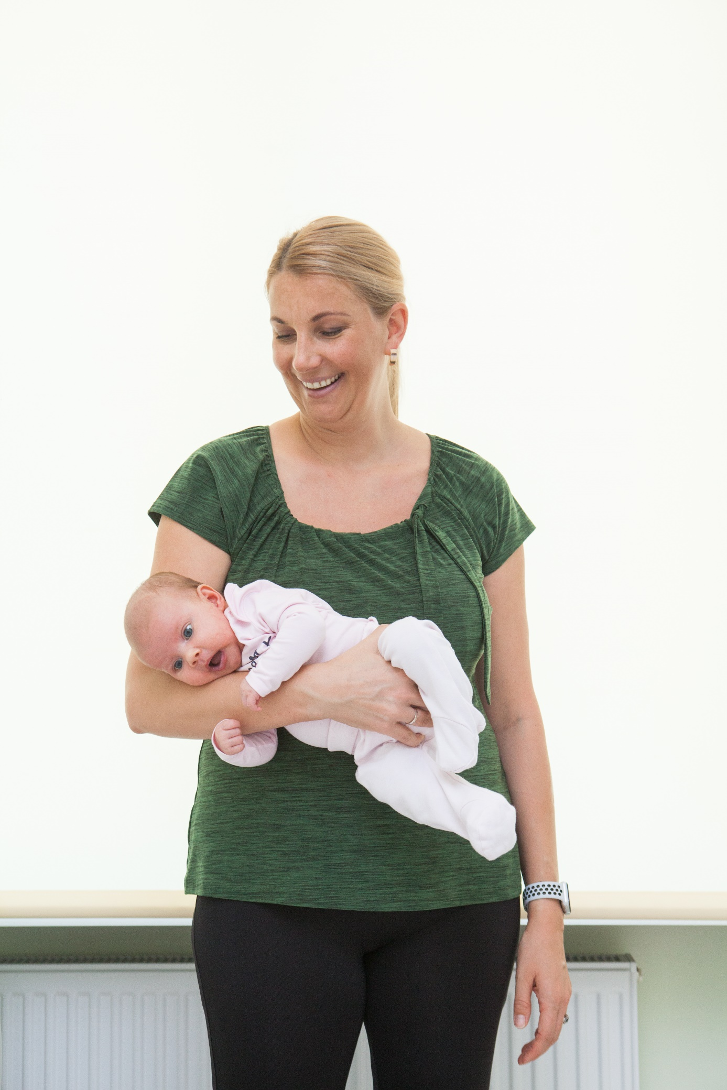
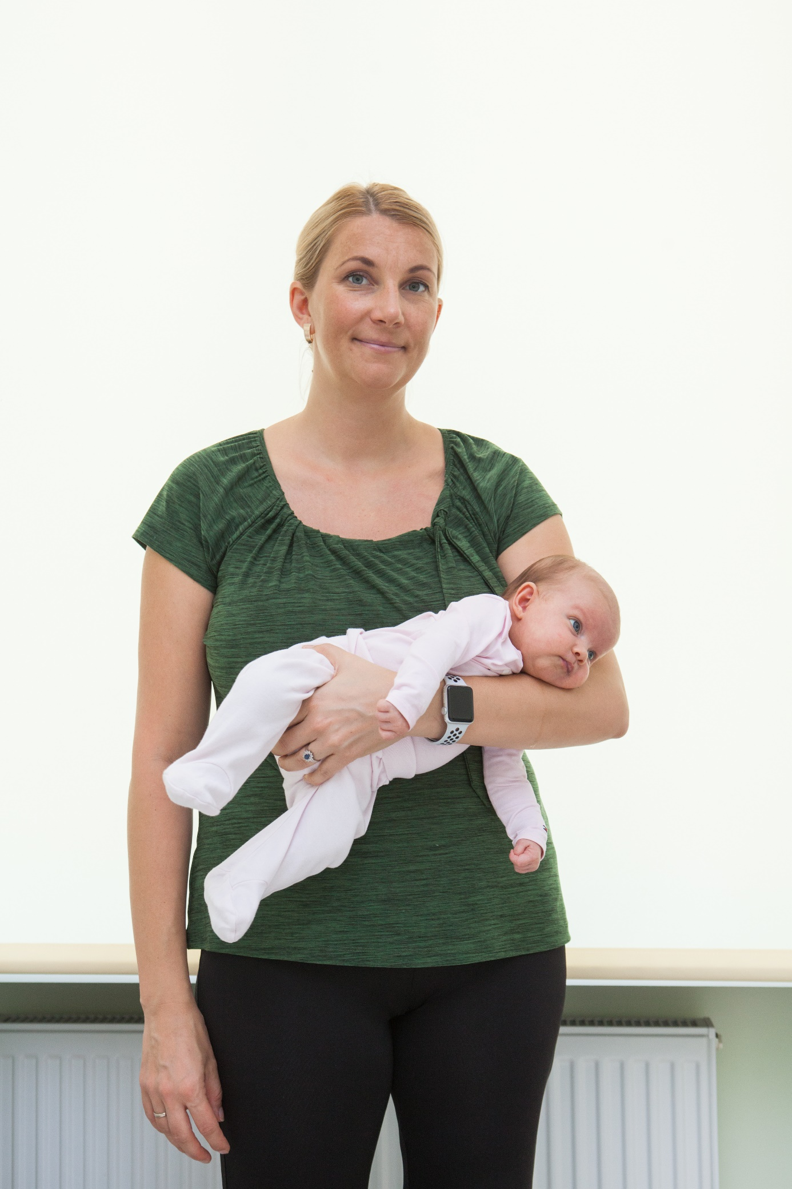
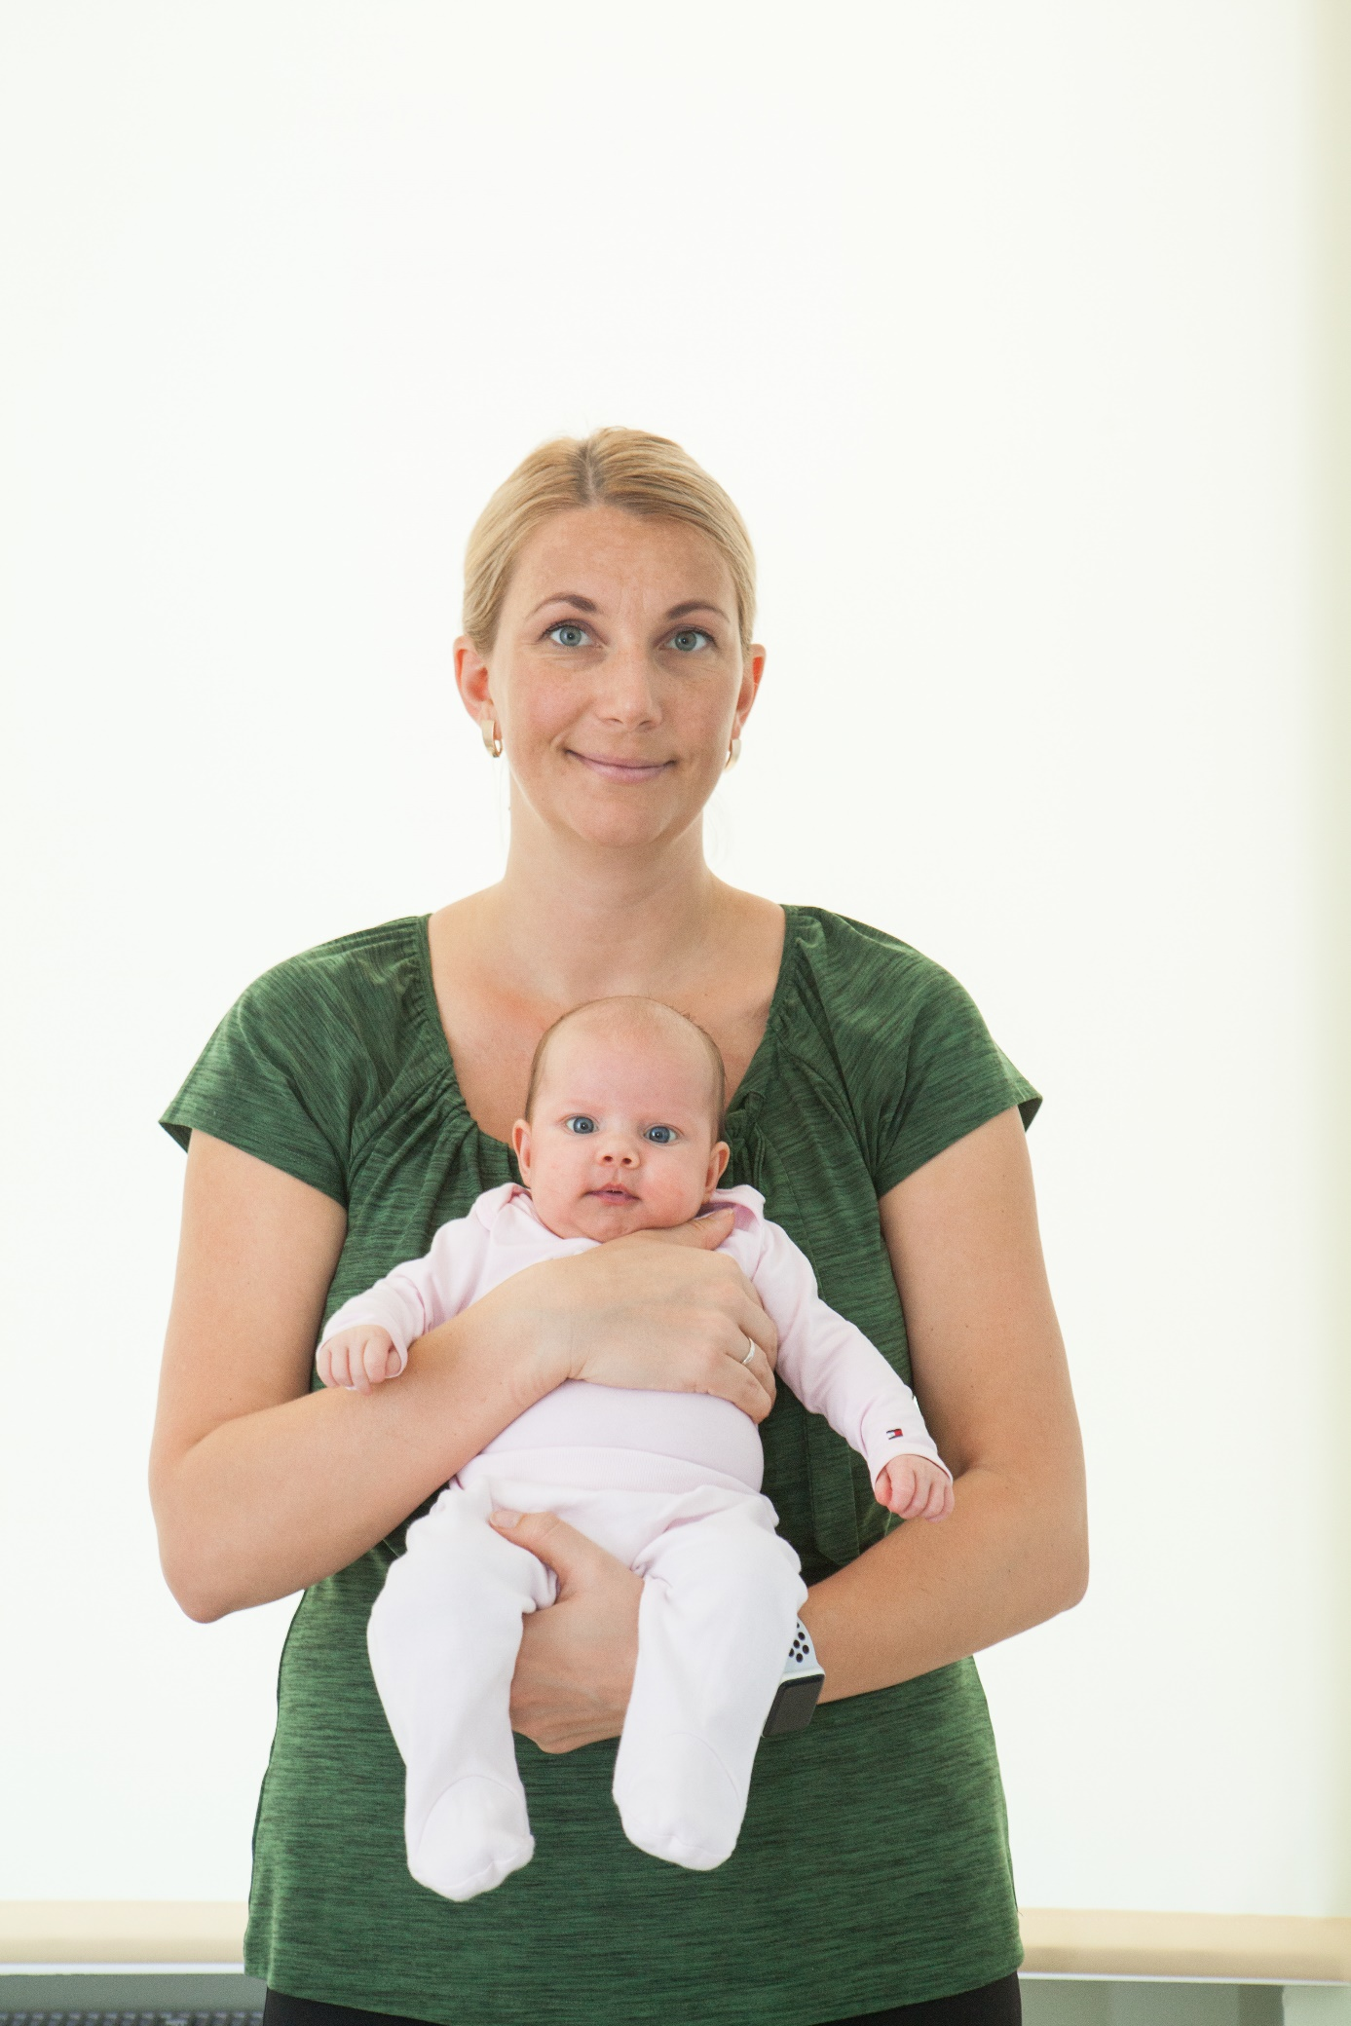
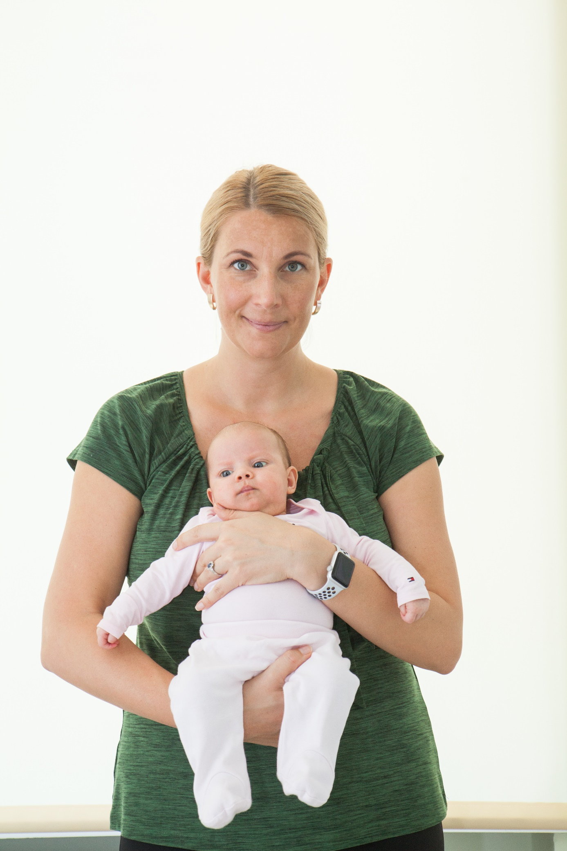

Avoid activities that require bending forward for extended periods of time. When bathing your baby, ensure the bath is positioned at a suitable height. When lifting your baby or objects, always hold the weight close to your body. Keep your back straight and lift with your legs.

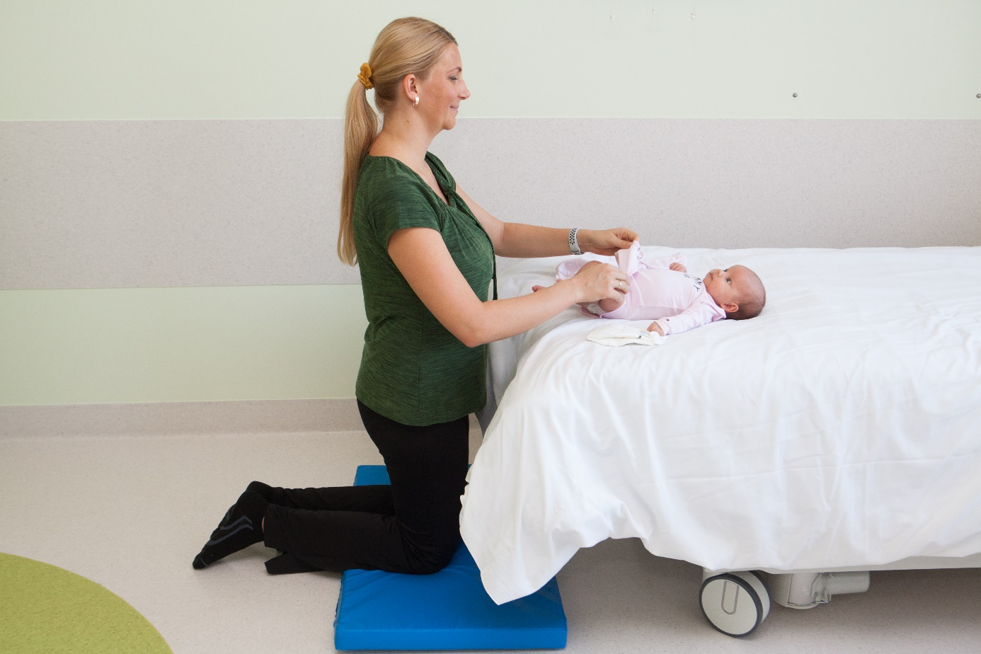
Any surface used for changing should be at the level of your hips.
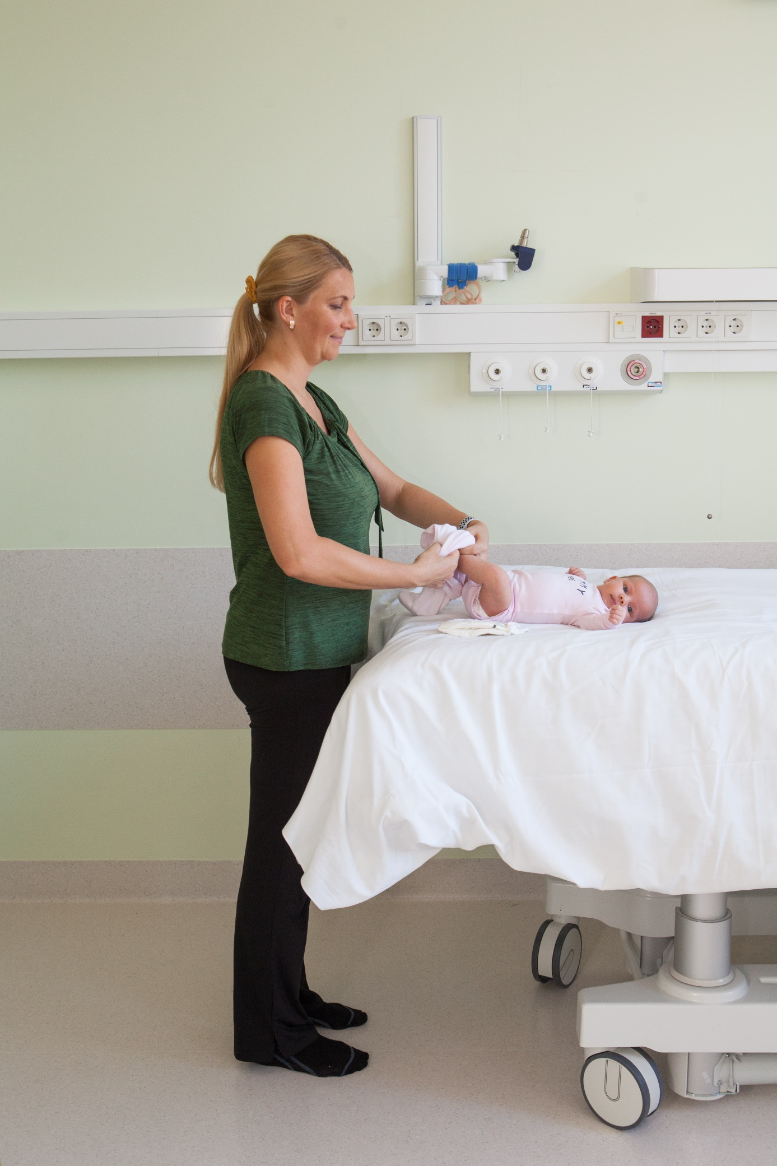

Use different positions for rest. When lying on your back, place a pillow under your knees to relax your back muscles.
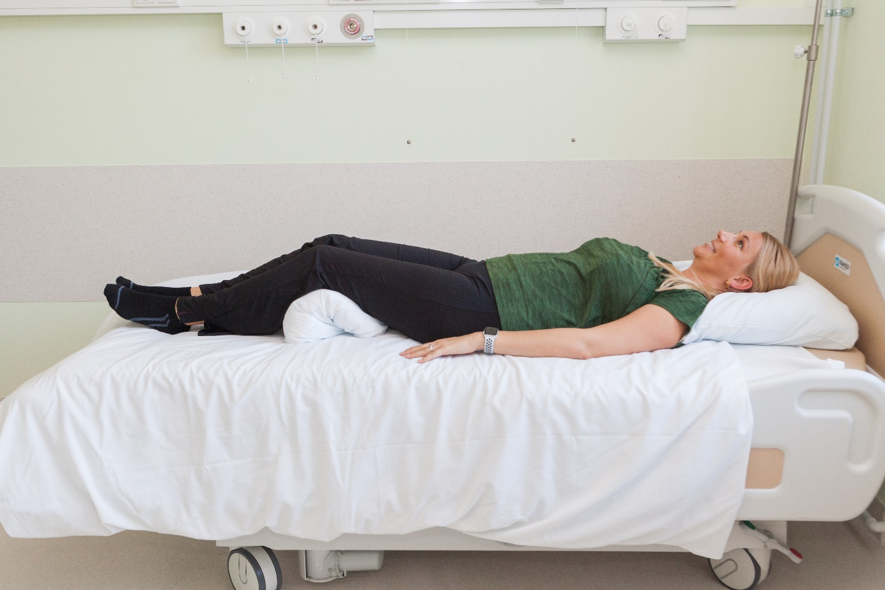
When lying on your side, place a pillow between your knees to relax your back muscles. When you are breastfeeding, you may also lie on your side next to your baby.
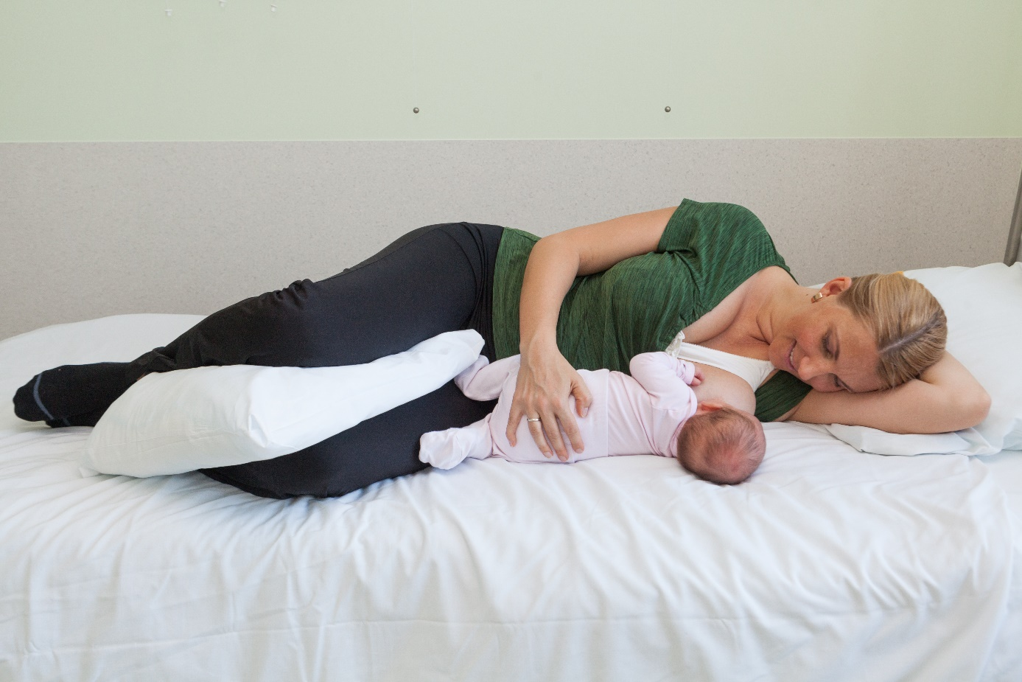

While breastfeeding in a sitting position, support your lower back with a pillow. During breastfeeding, use pillows to raise your baby to breast height. This will prevent you from bending forward.

For the bladder function to return to normal, try drinking at least 2–3 litres of fluid a day and going to the toilet every 2–3 hours. This helps to prevent the bladder from becoming over-distended, as the bladder may fill with urine faster after pregnancy. It may take some time for normal bladder sensations to return. When sitting on the toilet seat, place your feet firmly on the ground to relax your pelvic floor muscles.

For the bowel function to return to normal, go to the toilet when you feel the urge. Having a bowel movement between three times a day and three times a week is considered normal. Eat fresh fruit and vegetables and avoid semi-finished products. Avoid constipation and severe pressure on the pelvic floor. To facilitate bowel movements, rest your feet on a small stool, support your arms or elbows on your thighs and relax your abdominal muscles.

Exercises for strengthening pelvic floor muscles

Start with pelvic floor exercises immediately after delivery (within the first 24 hours), even if you have stitches or swelling. Mild exercising helps to improve circulation and reduce swelling.
Starting position - lie on your back with your knees bent and feet flat on the ground. Breathe calmly and keep your leg muscles relaxed.
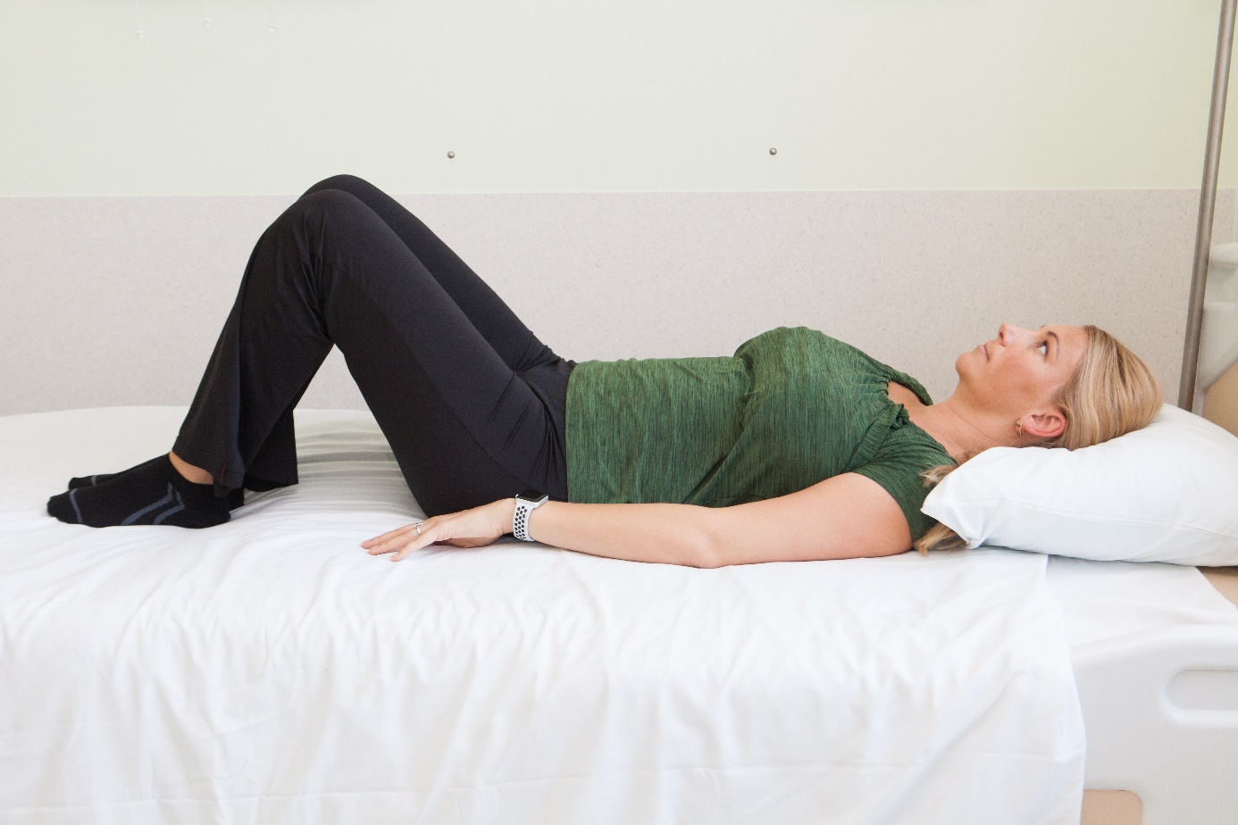
Tighten and pull up the pelvic floor muscles as if trying to stop yourself from passing urine or wind. Then relax the muscles completely for four seconds and repeat the exercise. Try to do pelvic floor exercises 4–5 times a day. At first, do the exercises while lying on your back. As soon as you can, start exercising while standing and then while sitting down. Tighten the pelvic floor muscles when you cough, sneeze, laugh or lift and carry your baby.
During the first six weeks, try to lie down for at least one hour during the day to reduce pressure on the pelvic floor.

Exercises for activating abdominal muscles

Abdominal exercises are very important after childbirth. Try to do 10–15 repetitions twice a day.
Abdominal breathing - lie on your back with your knees bent and feet flat on the ground. Breathe in through your nose so that your stomach expands and exhale through your mouth so that your stomach flattens. Make sure your chest does not move. Allow the stomach to move freely. As you breathe out, pull your stomach towards your spine and hold the tension for as long as the out-breath lasts. Try to do the same while lying on your side with your knees bent.
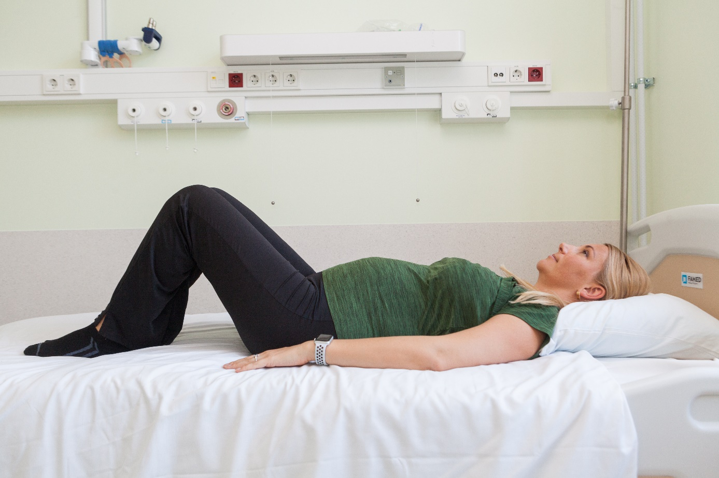

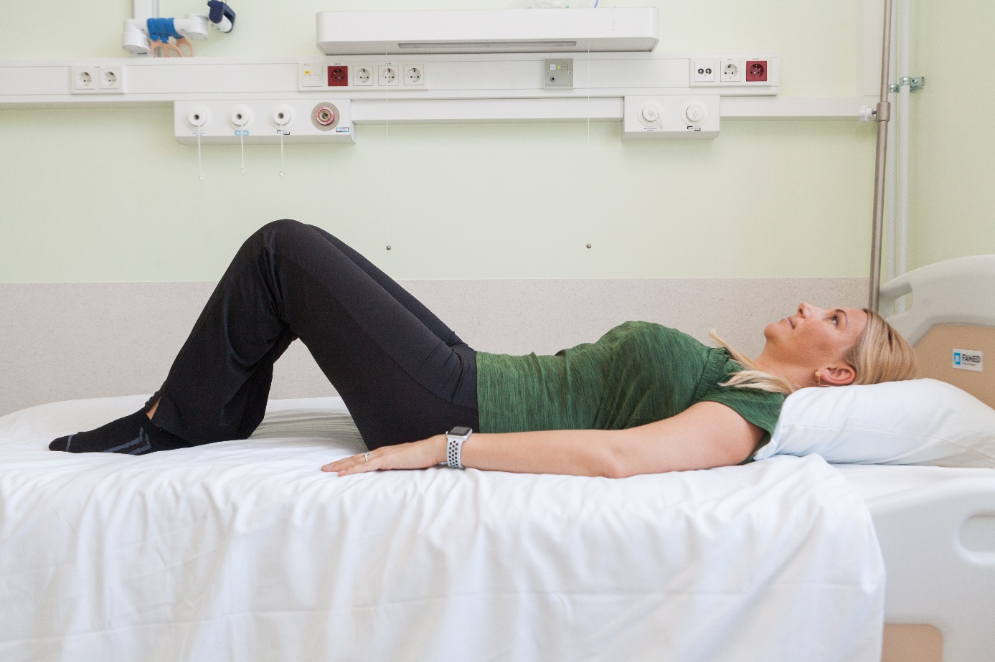

Pelvic lift - lie on your back with your knees bent and feet flat on the ground. Tighten your buttocks, pelvic floor muscles and abdominal muscles and lift up your pelvis, buttocks and back at the same time. Hold the position for 5 seconds and then relax. Repeat the exercise 10 times. Breathe out as you tighten your muscles. Avoid overextending and rolling onto the neck.
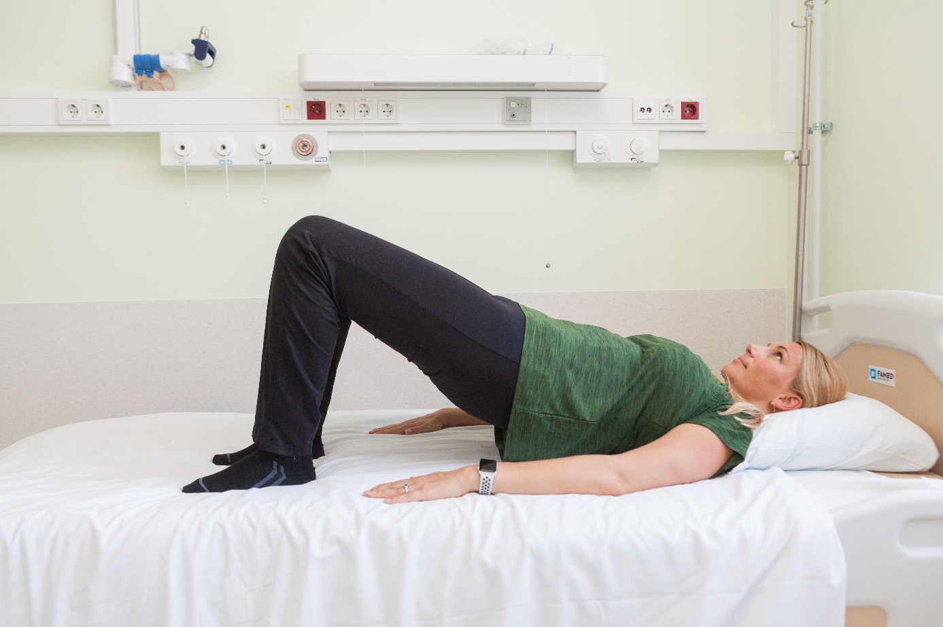
Heel slide - lie on your back with your knees bent and feet flat on the ground. Slide your heel along the ground until you can keep your core muscles tight. Return to the starting position. Repeat the same with the other leg. Breathe out as you tighten your muscles.
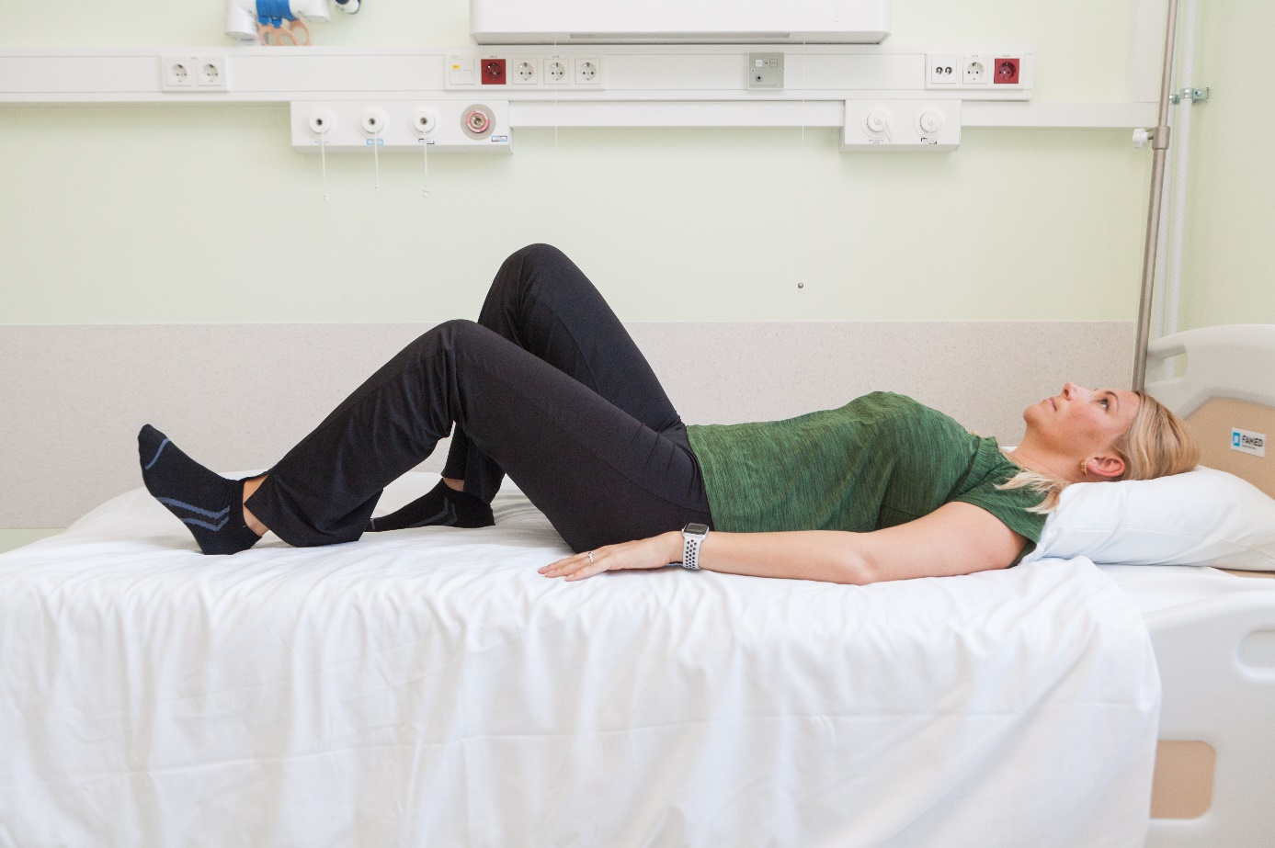

Recovery takes time and varies from person to person.

The time needed for recovery varies from person to person. Try to avoid activities that cause discomfort. Walk a lot to increase your endurance. Start with a short distance in the first week (10 minutes) and gradually increase it according to your comfort level. For the first 6–8 weeks after delivery, it is not advisable to have sexual intercourse, take a bath, swim or exercise intensely.

Contact your doctor or physiotherapist within 2–4 months after delivery if you have:

- urinary incontinence and/or flatulence when coughing, sneezing, lifting weights or engaging in other activities;
- a sense of vaginal heaviness;
- weak abdominal muscles, abdominal distension;
- back or pelvic pain that interferes with everyday life;
- pain in the pelvic region, in the anterior umbilical region of the abdominal wall or lower down: also in lower back, sacrum or buttocks;
- umbilical hernia (bulging belly button);
- urinary or faecal incontinence in case of full bladder or rectum;
- difficulty in performing daily activities due to pain, incontinence, tension or other worrying symptoms in the pelvic area.

ITK1059
Approved by the decision of the Care Quality Commission of East Tallinn Central Hospital on 10.11.2021 (protocol no. 16-21)

